


Scope and Storyboard for
Instructions to Counsel

AMR Manchester

By AKR

Table of Contents

1. Document Revision History 2
1.1. Document Location 2
1.2. Revision History 2
1.3. Approvals 2
1.4. Distribution 2
2. Summary of Scope 3
3. Screen design 3
4. Workflow 7
5. SQL Tables 8
5.1. Table 8
5.2. Lookup 8
5.3. Field 8
6. Stored Procedures 8
6.1. Fetch 8
6.2. Save 8

Document Revision History

Document Location
Full File Path

Revision History
Version Number | Revision Date | Summary of Changes | Changes marked | Author
0.1 | 26-07-2011 | First issue | n/a | AKR

Approvals
Name | Signature | Title | Date of Issue | Version
Gareth Levingston |  | Senior Business Analyst

Distribution
Name | Title | Date of Issue | Version

Summary of Scope

When drafting a defence you have the option for Counsel to draft instead of a lawyer. This scope describe the provisions that need to be made to the FloCase system in order for it to handle the process of sending instructions to counsel on an ad hoc basis.

2.1 Instructions to Counsel Description

When you instruct a barrister to do work (whether advising, drafting paperwork, or representing someone in court) this is known as ‘instructing counsel’ or ‘briefing counsel’. These terms are interchangeable.

When instructing a barrister, unless the matter is urgent, it is normal for the barrister to receive a document known as ‘Instructions to Counsel’ or ‘Brief’. Traditionally, this has been a document prepared by a solicitor for the barrister which aims to set out in summary form what the case was about, what documents were being provided to the barrister, and what the barrister was being asked to do and by when.
You do not have to prepare a 'Instructions to Counsel' document but it can help your case get off to a good start if you do. Sometimes you may only need to prepare a covering letter.

Screen design

Letters for instructions to Counsel:
1) Ad hoc letters
2) Brief to Counsel (To attend Trial)
3) Draft Instructions to Counsel (To Draft a defence/ draft admission) (COVERED IN DEFENSE SCOPE)

Documents:

Instructions to Counsel Ad hoc Flow:
1) Instructions to Counsel – already on flocase
2) Ad hoc letter to Counsel enclosing instructions – required on FloCase in Defence flow

3) Letter to insured enclosing defence for signature
4) Civil Justice Reforms information leaflet

Brief to Counsel Ad hoc Flow:
5) Brief to counsel – required on FloCase in Applications flow
6) Ad hoc letter to Counsel enclosing Brief – required on FloCase in Applications flow

a) Instructions To Counsel - Task is available for selection from the Case Action screen

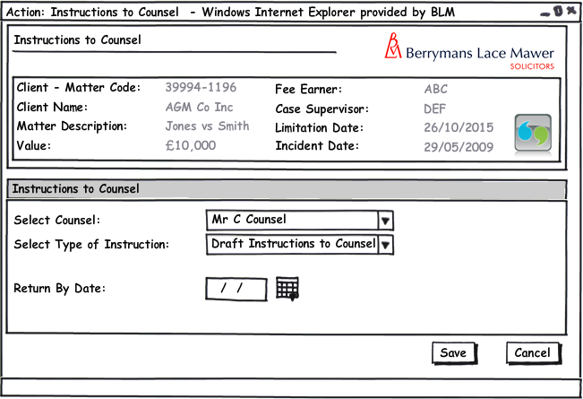
Figure 1 – Draft instructions to Counsel

Form Availability
Form should be available for selection from the Case Action screen

Form Behaviour on Load:
State pre-populated data….

Form Items:

- Select Counsel: Links to list of Councils and their addresses. All Active Counsel Contacts attached to the Matter populate via LTMM_CaseContacts_Fetch passing in contact type = ‘COUNSEL’ and the CaseID of the matter being Accessed

- Select Type of Instruction: Dropdown list: ‘Draft Instructions to Counsel’, Brief to Counsel’.
- Return By Date: Date Field –Date instruction needs to be returned

Form Behaviour on Submit:
Should return to the Matter Landing Page.

If Type of instruction = ‘Draft Instructions to Counsel’
1) Produce an Instructions To Counsel Document and Ad hoc letter to Counsel enclosing instructions
2) Schedule ‘Draft Instructions Received from Counsel’ (Form 2) for the Team Administrator on the Matter for 1 working day.
3) Write History Line ‘Sent Instructions to Counsel on <date document created>’
If Type of instruction = ‘Brief To Counsel’
1) Produce an Brief To Counsel Document and Ad hoc letter to Counsel enclosing Brief
2) Schedule ‘Brief To Counsel –Attendance Confirmation’ (Form 3) for the Team Administrator on the Matter for 1 working day.
3) Write History Line ‘Sent Brief to Counsel to <date document created>’

Form Behaviour on Cancel:
Returns to Case Action screen.

b) Instructions Received from Counsel - Task is scheduled If Type of instruction = ‘Draft Instructions to Counsel’ in Instructions to Counsel screen

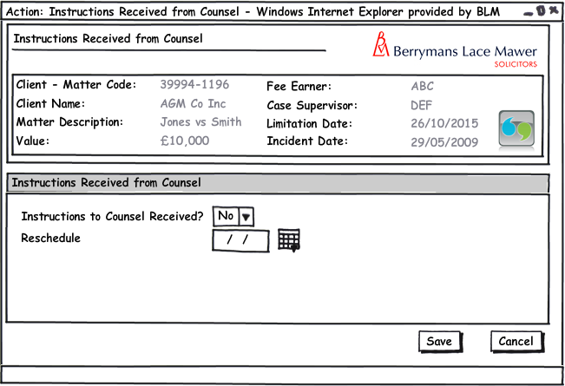
Figure 2 – Instructions Received from Counsel

Form Availability
Form should be not be available for selection from the Case Action screen but scheduled from Instructions to Counsel If Type of instruction = ‘Instruction To Counsel’.

Form Behaviour on Load:
This form should load without pre-populated data.

Form Items:
Instructions to Counsel Received? – Label as stated with associated Mandatory Combo box having the following options (Populated using LTMM_LookupCodes_Fetch with @LookupTypeCode = 'YesNo', @BlankRow = 1):
- Yes
- No
Reschedule – Label as stated with associated Date Picker. This control should only be visible if Instructions to Counsel Received? = ’No’ and should be mandatory if visible.

Form Behaviour on Submit
If Instructions to Counsel Received? = ‘No’ – Reschedule Instructions Received from Counsel (Form 2) for the Team administrator on the Matter for the date entered in Reschedule.
If Instructions to Counsel Received? = ‘Yes
1) If Receive Draft Defence user can manually select ‘Letter to insured enclosing defence for signature’ and a ‘Civil Justice Reforms information leaflet’
(these are manually selected as we are not recording the type of instruction received).
2) ‘System writes a History Line ‘Instructions from Counsel Received’

Form Behaviour on Cancel
Return to Matter Landing Page

c) Brief to Counsel- Attendance Confirmation - Task is scheduled If Type of instruction = ‘Brief to Counsel’ in Instructions to Counsel screen

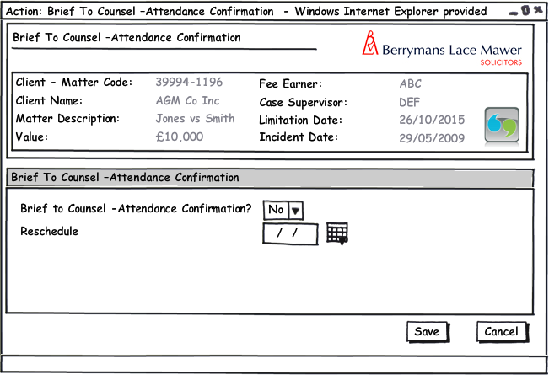
Figure 3 – Brief to Counsel –Attendance Confirmation

Form Availability
Form should be not be available for selection from the Case Action screen but scheduled from Instructions to Counsel If Type of instruction = ‘Brief to Counsel’.

Form Behaviour on Load:
This form should load without pre-populated data.

Form Items:
Brief to Counsel Response Received? – Label as stated with associated Mandatory Combo box having the following options (Populated using LTMM_LookupCodes_Fetch with @LookupTypeCode = 'YesNo', @BlankRow = 1):
- Yes
- No
Reschedule – Label as stated with associated Date Picker. This control should only be visible if Brief to Counsel Received? = ’No’ and should be mandatory if visible.

Form Behaviour on Submit
If Instructions to Counsel Response Received? = ‘No’ – Reschedule Brief To Counsel -Attendance Confirmation? (Form 3) for the Team administrator on the Matter for the date entered in Reschedule.
If Instructions to Counsel Response Received? = ‘Yes’
1) Write History Line ‘<Counsel> confirmed hearing attendance’
2) Schedule Reminder Task: <Counsel> attending hearing on <hearing date>

Form Behaviour on Cancel
Return to Matter Landing Page

Workflow

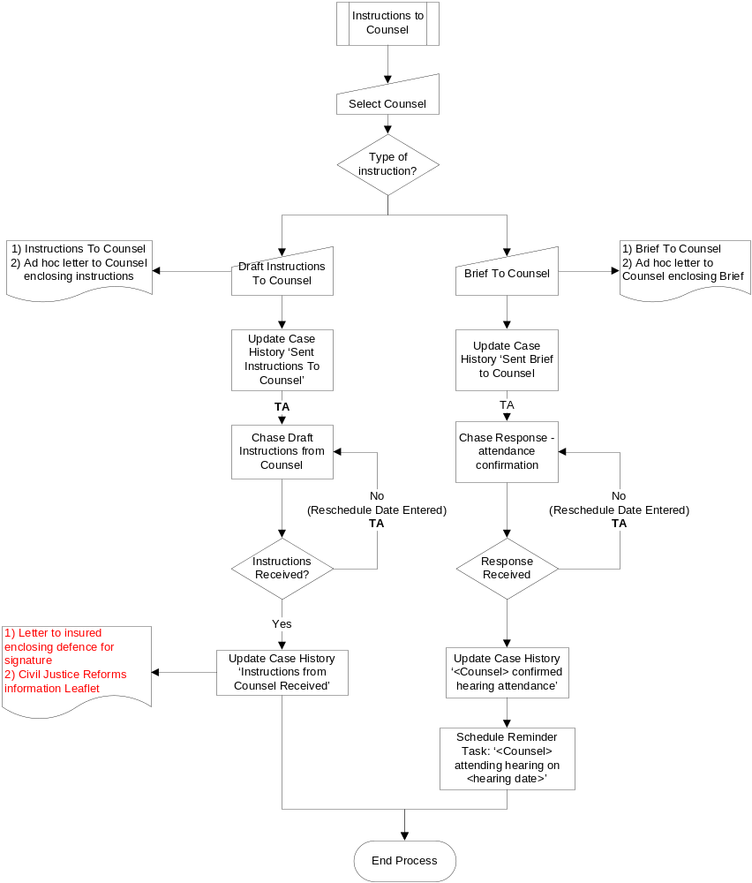

Navigation

Where will the Flow be launched from
The flow will be picked up ad hoc from the Case Actions screen

Where should the Flow return to
The flow will return to the homepage screen.

SQL Tables

Table

New table?

Lookup

Field
The only new field requirements are those described within the new tables section above.
Name: This column will contain the (label name) of the field
Field Type: This column should contain the type of the form field i.e. Textbox, Drop Down List, etc.
Mandatory: If the field is mandatory or not.
Rule: Any Special rule for the field – i.e. should the field only be visible in certain circumstances
Form: FloCase Form where field is located (if applicable).
Description: A short description of what the field is for.

Name | Field Type | Mandatory | Rule | Form | Description

Stored Procedures

Fetch

Save

Document Templates

Please list below details of any document required as part of this scope.

Status:  New / Existing/ Replacement  (please state) | Received Document Name (from business) | Document File Name  (ie Document.dot) | Document Description  (as viewed on FloCase) | Template Description Code  (Code for auto description) | Template Group:  BLM/ Documents/ Court Doc/ Letters/ Other | Availability? (Flow Only, Ad hoc or Both)
WorkFlow:
Existing | Instructions to Counsel | Counsel_Instructions.dot | Instructions to Counsel | Ins. Cnsl | Documents | Both
New? | 50) Ad-hoc letter to Counsel enclosing instructions.rtf | Refer to Checklist -TBC | Refer to Checklist -TBC | Refer to Checklist -TBC | Letter | Both (also required in Defence and Application scope)
New | 77) Letter to insured enclosing defence to be signed.rtf | Refer to Checklist -TBC | Refer to Checklist -TBC | Refer to Checklist -TBC | Refer to Checklist -TBC | Both
New | 78) Civil Justice Reforms information leaflet.rtf | Refer to Checklist -TBC | Refer to Checklist -TBC | Refer to Checklist -TBC | Refer to Checklist -TBC | Both
New | 51) Brief to Counsel.rtf | Refer to Checklist -TBC | Refer to Checklist -TBC | Refer to Checklist -TBC | Documents | Both (also required in Applications scope)
New | 52) Ad-hoc letter to Counsel enclosing Brief.rtf | Refer to Checklist -TBC | Refer to Checklist -TBC | Refer to Checklist -TBC | Letter | Both (also required in Applications scope)

/tmp/lo/0000.doc

